[SiteMinder](http://ca.com/us/products/product.aspx?id=5262) is a centralized user authentication and single sign-on, policy-based authorization and allows access to Web applications and portals.

1. The SiteMinder address the problem of managing logins to heterogeneous web-based services.
2. For example, users that access a web service hosted on a Microsoft IIS Web server are authenticated by a Windows NT domain controller, which maintains user account information.
3. If the same users want to access web services on an iPlanet Web server running on a Sun server, they have to be authenticated by another mechanism, usually through LDAP.
4. Since there is no way to pass authentication verification between these two systems, users must log in twice.
5. SiteMinder solves this multiple login problem by providing a central point for all authentication.
6. Instead of being authenticated by each web service, users are authenticated by SiteMinder instead.
7. After the user is authenticated, a special encrypted cookie is created and used for subsequent logins to different web-based services and applications.
8. Even though users are automatically authenticated, access rights to specific resources are provided by policy servers.
9. The SiteMinder software consists of two main components:
   1. SiteMinder Policy Server
   2. SiteMinder Web Agent
10. The **SM Web Agent** needs to be installed on the Web Server. It was designed to intercept all traffic and checks to see if the resource request is..
    1. Protected by SiteMinder
    2. If the User has a valid SMSESSION (i.e. is Authenticated)
    3. If 1 and 2 are true, then the WA checks the Siteminder Policy Server to see if the user isAuthorized to access the requested resource.

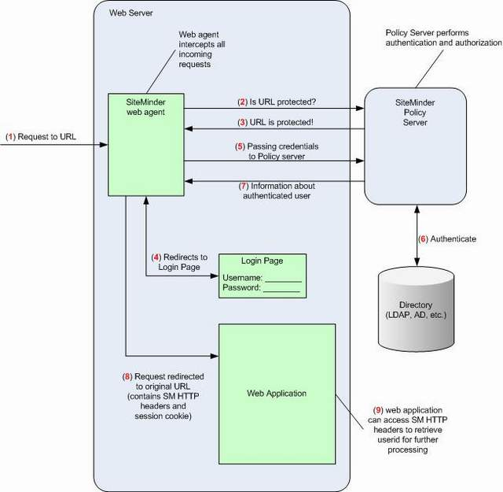

<http://stackoverflow.com/questions/10148666/how-can-i-trust-that-the-siteminder-http-headers-havent-been-tampered-with>